Contributions Request from the Friends of the Kodiak Fair & Rodeo

Welcome to 2022, a new year full of potential and excitement!

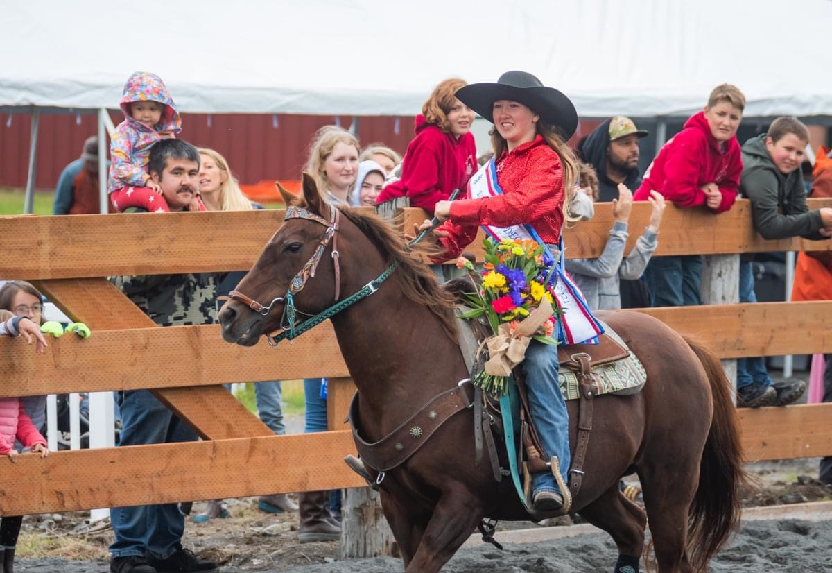
For over 50 years, the Kodiak Rodeo and State Fair has been a highlight event in our community with lots of great rodeo action, good food, and fun events. We do not know yet what this new year will bring, but we do know that we will work hard and do our best to host another great Kodiak Rodeo and State Fair that is safe and enjoyable for all, and we cannot do that without the generous support from our sponsors!

First, a big thank you to our past sponsors! Without the sponsorship of numerous businesses and individuals, we would not have financial stability. New sponsors are always welcome and we urge both spectators and contestants to support the Kodiak Rodeo and State Fair and our sponsors. The Kodiak Rodeo and State Fair takes place at the Kodiak Fairgrounds, where Board members and volunteers work tirelessly to keep the grounds cleaned and maintained, and dedicate time to planning and producing fun events.

Our Labor Day fair and rodeo is by far our largest and longest-standing event offered for the whole community. Kodiak residents and visitors have opportunities to watch and participate in the state fair and western style, family rodeo. Each year people of all ages look forward to exhibiting their handiwork at the fair and competing with their neighbors for blue ribbons, buckles, and bragging rights. Our rodeo draws competitors from across the state, including the Alaska State Highschool Rodeo team which comes every year to compete. Spectator participation and kids’ games make this a fun family event.

Other events offered over this past year included 4-H programs, Equine Therapeutic Riding, concerts, drive-in movies, gardening, horseback riding lessons, Kodiak Summer Series, Boy Scouts of America, weddings, Kodiak Annual Children’s Fair, Pumpkin Patch, and more! We strive to make the Kodiak Fairgrounds a place for families, friends, and neighbors to gather and recreate safely. It is a place for us to connect with the next generation.

Throughout the year the Kodiak Fairgrounds supports local nonprofits by providing a venue for them to reach out to the community. Some of the organizations that rely on using our facility include the 4-H youth programs, CPOA, Kodiak Lions Club, Kiwanis of Kodiak, Therapeutic riding program, and so much more.

Over this past year, we have also been busy securing grants to improve our venue space. A new outdoor arena was built just in time to host the annual rodeo, we secured funding and anticipate the completion of a bathroom renovation this spring, we are working on gathering volunteers to help us expand our community garden, and we are actively seeking funds for a new roof for the indoor arena and bleachers for better viewing of the outdoor arena.

In 2022, we are planning a large rodeo and fair geared towards bringing statewide contestants and spectators. We will continue to offer the fairgrounds space in support of local non-profit events and for rent. We will continue the long-standing horse boarding services and will work on improving drainage on the grounds. We are working hard to create a space where we can gather safely with our friends and neighbors, and none of this can be done without the generous support of our sponsors.

On behalf of the Friends of the Kodiak Fair & Rodeo, thank you for your past support and for supporting us into the future. As a bonus, in 2020 we established the Friends of the Kodiak Fair and Rodeo as a 501(c)3 non-profit meaning all of your donations are now 100% tax deductible!

Sincerely,

Sylvia Kavanough, President
Friends of the Kodiak Fair & Rodeo Board of Directors

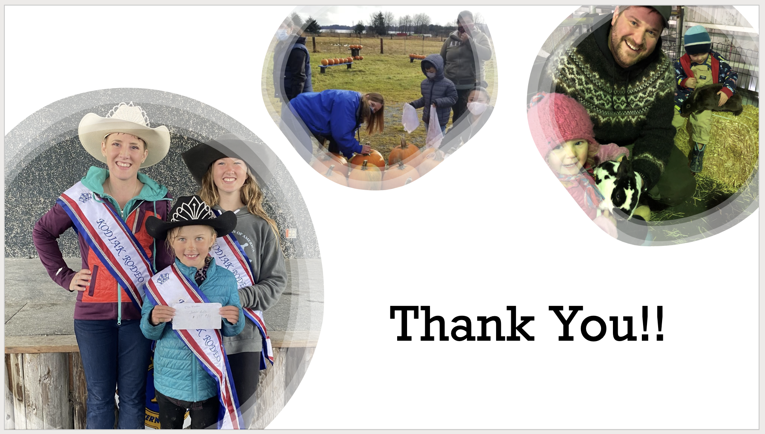

 | Advertising | Banners | Tickets | Booth | Goal
Gold Sponsor $3,001-$5,000 | - Mention in all radio & newsprint ads promoting the fair  - 1/2 page ad in program  - Announced as a Gold sponsor throughout the event  - Logo on t-shirt and website | 2 | 60 Fair & Rodeo passes | Yes (non-food) | 5
Silver Sponsor $1,001-$3,000 | - Mention in all radio & newsprint ads promoting the fair  - 1/4 page ad in program  - Announced as a Silver sponsor throughout the event  - Logo on t-shirt and website | 1 | 45 Fair & Rodeo passes | Yes (non-food) | 10
Bronze Sponsor $501-$1,000 | - Mention in daily program and newsprint ads | 1 | 30 Fair & Rodeo passes | Yes (non-food) | 15
Blue Ribbon Sponsor  $250 - $500 | - Mention in daily program |  | 20 Fair & Rodeo passes |  | 50
Friends of the Fair  >$250 | - Sincere appreciation!

Sponsorship Agreement

I wish to sponsor at the following level: _______________________________________, in the amount of $_______________.
Paid now Please bill I will provide a banner to be displayed at the Fair. Yes No

Business name _________________________________________________________________
Contact person _________________________________________________________________
Address ______________________________________________________________________
City _________________________ State ______ Zip ___________ Phone _________________
Date ____________________ E-mail address:___________________________________

Please make checks payable to Friends of the Kodiak Fair and Rodeo PO Box 507 Kodiak, AK 99615 / For questions, contact Marian Royall (907) 539-1734

